**Swiss Engineering Event App (SEEA)**

**Projektarbeit IP5-FS19**

Client: Swiss Engineering Verband  
Author: Waleed Al-Hubaishi  
Coaches: Prof. Dr. Doris Agotai

Ms. Madlaina Kalunder  
Ort, Datum: Brugg, August 2019

|  |
| --- |
| **Swiss Engineering Event App**  Projektarbeit IP5-FS19 |
| **Autor** |
| Waleed Al-Hubaishi Pappelweg 7 8404 Winterthur waleed.alhubaishi@students.fhnw.ch |
| **Dozentin** |
| Prof. Dr. Doris Agotai Fachhochschule Nordwestschweiz  [Doris.agotai@fhnw.ch](mailto:Doris.agotai@fhnw.ch)  Ms. Madlaina Kalunder Fachhochschule Nordwestschweiz  Madlaina.kalunder@fhnw.ch |
| **Auftraggeberschaft** |
| Swiss Engineering Verband STV Thomas Hauser Langackerweg 10 5303 Würenlingen thomas.hauser@avaloq.com |
| Brugg, August 2019 |

# Abstract

Swiss Engineering Association offers its members a variety of events to book via its platform, but as the technology develops rapidly, an app has become a necessity to make the booking process easier for members who do not to prefer use the internet browsers on their small smartphone screen.

The objective of this project is to facilitate booking events process using the apps, so that the Swiss Engineering members can totally rely on it to manage their booked events and explore what is available on the platform. VOICE FEATURE

The app has been implemented using XAMARIN Cross Platform app developing tool to ensure that no matter which device do the members have in their pockets, they will enjoy the intuitive experience of booking, managing and exploring the events.

The mixture of working with Agile methods while focusing on the usability experience (UX) resulted in an intuitive to use graphical user interface, where all important elements related to the core features of the app are well presented in the home page screen, so that the end-users, no matter what age group they belong to, or what technical affinities they possess can enjoy the app and use it without any tutorials on how to navigate through the different app screens.

~~This Document will discuss how those features are implemented, and focus in details on the Voice Assistant feature as it is considered to be the main feature and added business value.~~

Table of Contents

1. Introduction 5

1.1 Problem Statement 5

1.2 Project Vision 6

1.3 Project Approach 6

2. Research 7

2.1 State Of the Art 7

1.1.1Automatic Speech Recognition 7

2.1.1Multilingual Speech Recognition 8

2.1.2Visual-only recognition of normal, whispered and silent speech 9

2.2 Methodologies of Voice Extraction/Recognition 11

2.2.1Feature extraction 12

2.2.2Voice Classifier/Identifier 13

2.3 Topic in depth 15

2.4 Technical research 17

2.4.1Built-in Voice Assistants 17

2.4.2Plugins for Text-To-Speech 24

2.4.3Programming Language 26

2.4.4Chatbot service platforms 29

3. Concept 33

3.1 Approach 33

3.2 App Map 33

3.3 Persona 34

3.4 User Interface 34

3.5 Requirements 34

3.6 Social Factor 35

4. Prototype 36

4.1 App main features 36

4.2 Core implemented features 37

4.3 Explorative features and functionality 40

4.4 Mock-ups 43

5. Implementation 46

5.1 Talk To SEEA 46

5.1.1Handling users input 47

5.1.2Extracting the tag from the users input 52

5.1.3Generating SEEA response 53

5.2 Search for events 55

5.3 Get Inspired 57

5.4 Profile 58

5.5 Saves Locker 60

6 Analysis and future thoughts 66

7 Refrences 69

8 Appendix 73

# Introduction

Swiss Engineering is an association that spans over multiple professions and has a total of around 13’000 members in Switzerland. They are holding over 100 events annually over multiple of their Sections. These events are not only for current members also have the additional benefit of attracting new future members.

The Swiss Engineering association is currently in the process of updating their event booking website (see figure 1). To reach a greater audience they intend to also have a native mobile app to make booking on the go easier. This application would also be showcased on events with the idea to improve the image of the Swiss Engineering by showing that it has a modern app.

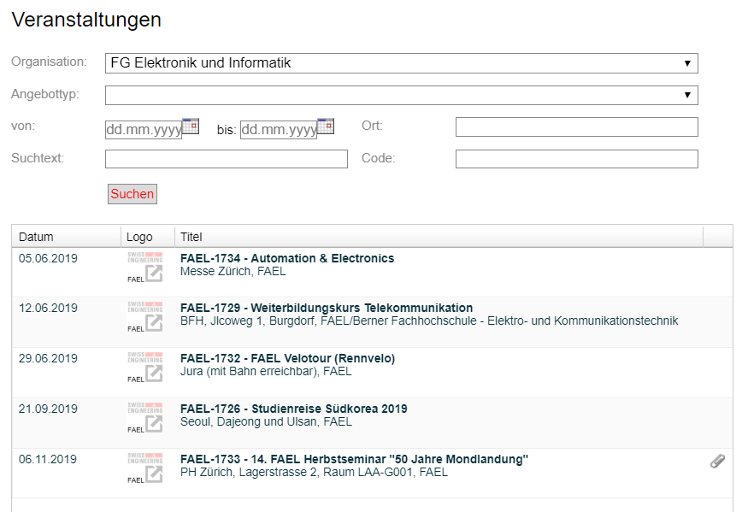

Figure 1 Swiss Engineering events platform

## Problem Statement

The Swiss Engineering Website gives the users the possibility to search for events and book them online, but as the website is designed mainly to work on personal computer’s browsers, the lack of mobile browsers support doesn’t offer a great experience for either searching or booking events, as the user interface elements are not placed optimally on the screen and some are completely hidden unless the user scrolls.

In addition to this limitation, the website doesn’t offer any kind of extra added values to the users, and the main and only function is to search and book events without any degree or possibility to customize or personalize the user experience while doing so.

The extra added value must help to retain the Swiss Engineering members, and make them tend to use the app in the future to book their events.

The Swiss Engineering Association also requested to have a voice assistant feature included in the app, with no specification on how such a feature shall be integrated or been used, so it is the duty of the team to find a user intuitive function, that can encapsulate the voice assistant feature.

## Project Vision

The IP5-Swiss engineering event app team aims to build an app with a simple UI design that helps the Swiss Engineering members to accomplish their goals at a glance and reach the needed piece of information within a sequential and logically ordered number of screens, so that no tutorials are needed to know how to use the app and also all Personas can use the app intuitively no matter which technological affinities they possess.

## Project Approach

As there was no given requirements to implement from the client (Swiss Engineering Association), and one of the main goals set was to retain the members, the team decided to follow the User Centric Design (UCD) approach, as it will offer in return a high level of User Experience (UX). [1]

A sample of the Swiss Engineering potential members were responsible of delivering their requirements and needs, which were then implemented in correlation with the business goals and the information provided by the client.

# Research

After presenting what is the team of SEEA aiming for, now is the time to start exploring what is available on the market, and what are the latest technologies used on the field to accomplish one of the most important features in the project, which is the built in assistant.

In the following chapters the latest developments to the Voice Recognition field will be discussed, and how could those benefit the app greatly.

## State Of the Art

This chapter includes the state of the art algorithms that are used nowadays in the Speech Recognition field.

Some of the algorithm that are discussed and explored in this section are not related to the goal of the voice assistant in this project, rather an interesting algorithms that might be added in the future to extend the algorithm used in the project and add extra value and functionality.

One of the major researched algorithms was the Lips Movement speech recognition as it will provide the opportunity to implement the search event feature for instance via speech recognition, where the end-user must not say the words out loud when the situation is not suitable for that.

### Automatic Speech Recognition

the idea of Automatic Speech Recognition **(ASR)** is to translate the input voice into a written text. And because of the recent development, such algorithm exists nowadays on the majority of smart phones via the built in voice assistant apps such as Google assistant for Android devices and Siri on iOS devices, not only that but on every single smart speaker that contains the voice recognition such as amazon Alexa.

Those ASR models have benefited greatly from the development of deep neural networks, yet there is still a major challenge ahead, such as dropping out a big part of the training data, and had therefore a hard time sometimes recognizing a word when the training data dropped out contains the set of parameters containing this word.

Data augmentation has helped a lot regarding this matter, the same way it helped before in the process of classifying images. The way it is used in the process of ASR is to extend the number of data used to train, not by adding more learning data via adding new large sized files, but by manipulating the existing data to offer another version with different parameters (see figure 2), for instance the voice can be used as is to provide one learning data, then speeding up or lowering it down to provide two different versions of the same original data used. [2]

~~This trick may be applied the same way it is applied in the image processing and classifying, by not manipulating the image itself, or the voice in our case, but manipulating its corresponding spectrogram to create a different version of the same uploaded file that will require no more extra space. The results were surprisingly good, and effective.~~

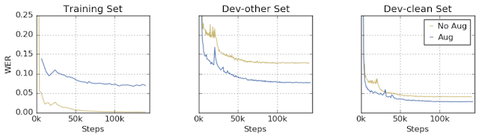

Figure 2 training data with two other versions created from original (<https://ai.googleblog.com/2019/04/specaugment-new-data-augmentation.html>)

### Multilingual Speech Recognition

This model provides the possibility to combine multiple languages ~~under the same model~~, ~~so that at the end the~~  this results in the algorithm being able to classify the language of a sentence.

The algorithm idea is not new, rather it is an improvement over an already existed model (Listen-Attend-Spell attention based sequence-to-sequence ASR by William Chan) so that it can be adapted to help the purpose of differentiating the languages.

The idea of this algorithm is to include a set of languages, per say L1 … Ln in a set L, and also include their corresponding characters in a set for each C1 … Cn, also the language specific training data set which consists of (X1,Y1) for the first language till (Xn,Yn) for the language Ln.

A big set is constructed, that contains all the training data sets, and another set (C) which contains all the characters. Afterwards the big training data set is used to train the model, with no indication given which language does this training data set belongs to.

This test has been done over 9 Indian languages, which have a rare percentage of intersection of words and characters, so a small number of words may be used in more than one language, in this case the word X for instance will have most of the times only one language which it belongs to as the number of intersection is very limited, so the total number of words recognized will help to identify the language used according to the number of similarities of the recognized words and each language set (the set with the highest number of matches wins). [3]

So at the end when the model finishes recognizing the words, a probability is calculated to determine to which language does this sentence belong, based on how many words came from each language separately, thus the language with the highest probability will most likely be the one which the sentence belongs to. [3]

### Visual-only recognition of normal, whispered and silent speech

Another state of the art algorithm that might be helpful to use in the noisy or in contradiction the loud places is the visual speech recognition.

The idea behind the visual speech recognition is to not use the voice to recognize the words but rather to use the lip movement.

This model will not use the microphone or audio files to get its learning data but it will use the video instead to detect the lips movement (see figure 3) and link it to the desired word, but as the header indicates, this model is not only about silent speech, but also whispering and talking out loud as well as talking normal.

Figure 3 capturing the lips movement (Source: https://ibug.doc.ic.ac.uk/media/uploads/documents/normalwhispersilentdb.pdf)

This is why the algorithm requires that data sets for 4 different models (normal, loud, whisper and silent speak) are trained in the same algorithm. The question raised is whether or not could the AI return the correct interpretation of the movement when the model(context) is not specified while testing.

The results out of testing this algorithm showed a big success and state of the art results when the context has been set and the training data has been provided while testing. On the other hand the performance dropped by a big margin when the model(context) has not been set, or when the training data of the used model was not provided but another model training data. [4]

## Methodologies of Voice Extraction/Recognition

The voice recognition is considered to be another input alternative rather than the textual classical way of entering input to the machine via keyboard. In this sub-chapter the various types of voice detection and recognition shall be introduced.

All different types of voice recognition requires two modes in order for it to work appropriately, which are:

#### Training mode

In training mode a huge amount of samples must be collected – the more the better – in order to train the system no matter if it was Speaker dependent or independent.

The samples must be words or even sentences captured by a microphone which is the input device in this case.

#### Testing mode

Acoustic/audible characteristics must be analyzed out of the input sample, and then the important features shall be extracted out of it.

The feature vectors are then used to generate an input pattern which will be saved in a form of a matrix, then the unknown pattern when entered must be compared with all the input values in the matrix, and the best match found should be considered to be the correct interpretation and perform the action that it leads to.

### Feature extraction

In this section the different types of feature extraction techniques are covered, which will be used afterwards to train the system. Feature extraction is done by changing the speech waveform to a form of parametric representation at a relatively lesser data rate for subsequent processing and analysis [5][6].

#### Linear Predictive Coding (LPC)

In LPC, the input speech in a frame-based manner is examined to produce vectors.

The LPC requires a pre-emphasize, which surpass the input speech, then the output of the pre-emphasizer must be blocked into frames, afterwards shall each frame be windowed, so that the amount of signal disruption can be reduced at the start and the end of each frame.

Finally each windowed frame is auto correlated, and the maximum value of the correlation is considered to be the order of the LPC analysis and used afterwards to return the LPC coefficient which is the result seeked (see figure 4). [7][8]

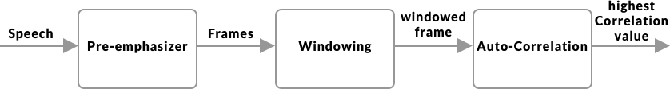

Figure 4 LPC flow diagram

#### Perceptual Linear Prediction (PLP)

It is similar to the LPC, but the captured speech must be adapted to the psychophysics of human hearing. Its spectral features differs from the normal LPC in way that matches the human auditory system, so therefor it rejects a lot inappropriate information (filtering) which might be caused by the speaker, but non-hearable by human frequency captured. [8]

#### Relative Spectral Filtering (RASTA)

This technique serves the same purpose as the PLP, but it helps to drop out/filter the voices (frequencies) caused by the background noises that are not related to the speech itself, so if this technique was combined with the PLP, then the results should be brilliant, then the Rasta passes each feature coefficient only.

It also includes a linear filtering of trajectory of power spectrum in the case of the noisy speech. [9]

#### Mel Frequency Cepstral Coefficient (MFCC)

The MFCC processing method is based on short-term analysis, which means that for each frame an MFCC vector must be computed, thus it is considered to be the best among all when it comes to estimate the human system response.

In order to obtain the coefficient (the result seeked in all types of speech recognition techniques) a hamming window must be applied to the input (speech sample) in order to reduce the disruption of a signal.

At the end a Discrete Fourier Transform (DFT) must be used to produce the Mel Filter Bank.

To calculate the MFCC the following formula can be used. [8]

### Voice Classifier/Identifier

So after that features have been extracted from the signals, those features should be used to train the system to classify the words spoken. Here is a list of most commonly used classifiers.

#### Hidden Markov Model(HMM)

This model is trendy and an easy approach when it comes to classify words. It is based on huge vocabulary speech recognition systems, characterized by a finite state Markov model and a set of output distributions, and automatically trained on large speech data for many hours, thus comes its major advantage which decreasing the time and the complexity required for training the huge vocabulary in the system. Unfortunately this advantage led also its major limitation, which is the complexity to find the error of its scheme in order to enhance the performance.[10]

#### Neural Network(NN)

Neural network are used mainly to solve complex identifications tasks, and they have also many number of advantages over the others, such as its ability to function independently of the speaker (unknown speaker) and its ability to work with noisy data. When compared to the HMM, the neural network provides much more better accuracy, especially when the amount of training data is large as HMM is used mainly when the number of training data is limited.

The neural networks is being used also in phoneme recognition, and therefore a combination called NN-HHM does exist, where HHM is used for the language modeling, and the neural network for the phoneme identification part. [11]

#### Dynamic Time Warping(DTW)

Dynamic Time Warping uses dynamic programming to perform the optimization process of identifying the similarities between two samples, the first is the original, and the second is the manipulated version of it. That is why it has been used to identify the manipulated versions of voice, video or even images. [12]

#### Vector Quantization(VQ)

VQ is basically a function mapping process, where it maps a word or input from a large space, into a smaller space called cluster, this cluster is identified by a code word, those collection of code words construct a code book.

Using the VQ method, a new codebook is constructed for each speaker, thus it may recognize the speaker even. This constructed codebook (see figure 5) acts as a pre-recorded words for the user, then used when the speaker is being tested to be identified or to recognize what does the speaker say in the system.

When it comes to Voice Recognition, the VQ is used to retain the high speaker recognition rate as a parameter to identify elements like number of speakers for instance as well as the size of training database.[13][14]

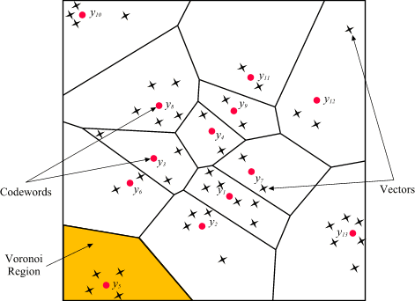

Figure 5 Codewords in 2-dimensional space. Input vectors are marked with an x, codewords are marked with red circles, and the Voronoi regions are separated with boundary lines (Source: http://www.mqasem.net/vectorquantization/vq.html)

## Topic in depth

This sub-chapter will go through the fields where the voice recognition is mostly used and in which context does it help to accomplish a specific purpose. At the first glance, one might think that voice recognition is used only for the smart assistant or voice messages, but it really did improve many other fields, that no one might consider the impact of voice recognition to those, and here are some.

### Evolving search engines

The search engines nowadays have become a necessity in our lives, but people do find sometimes difficulties expressing what do they really mean in verbalized words, and would prefer to say our query more naturally, and that is the biggest role of voice recognition in the search engines.

It is not meant that queries shall be searched via voice, although that is also an option on the major search engine such as Google for instance, yet it is meant that the search engine use the voice recognition training data entered daily and the intent behind it to give back better search results with high percentages of accuracy. [15]

### Communication in service providers

With the higher number of services available nowadays, therefor is the number of customers also huge, therefor the high number of technical support calls and guidance request, unfortunately that might lead to a long waiting periods on call till the customer been redirected to the technical assistant.

That has arisen the need of an innovative solution to help the customers get the guidance they needed in a short amount of time, thus is the voice recognition integrated.

In this situation the customer doesn’t have to enter any numbers using the keypad, yet the customer should be able to speak more naturally and let the smart assistant guide him/her through the problem solving process. [16]

### Voice biometrics as authentication

Voice biometrics description… This model has been used even in Switzerland by some companies, Sunrise telecommunication for instance, as they would ask the customer to use a sample of the voice to get its biometrics and construct a model so that the customer doesn’t have to give a number of personal sensitive data which might take a while before illustrating the customer’s request and intent of calling.

The voice biometrics are not only used in the services company, but also to authenticate the unlocking process of the smartphone and also to give commands to the virtual smart assistant. [17]

### Smart Assistant

Thanks to Amazon, Google and Siri, the smart voice assistant industry (see figure 6) is growing rapidly nowadays and companies compete to provide a better experiences to their clients to acquire a bigger market share.

Voice assistant helps to accomplish the major types of task, for instance setting up an alarm, playing music, calling contact, writing messages …etc.

Although a huge amount of people still consider the breakage of their own privacy, nevertheless the smart assistant is the considered to be the next big thing, especially when the companies start to expand the capabilities of the voice assistant as Google did for instant with the Duplex feature presented last year. [18]

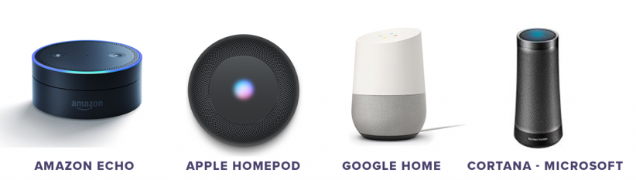

Figure 6 available voice assistants on the market (source: https://idfive.com/ideas/preparing-website-voice-recognition-usability/)

### Forensic Department

Although it may seem weird, but voice recognition has helped a lot so far in identifying criminals using their voice, in this case if a sample of the criminals voice was captured as the crime was committed, this sample can use later on to identify the criminal among a list of suspects by comparing their voices to the captured sample. [19]

## Technical research

This chapter will discuss the major technical issues related to the decision making processes during the project developing phase.

### Built-in Voice Assistants

This section will go into depth about which existing implementations for Voice Assistant applications are available, and their major features and characteristics

#### Google assistant

Google assistant is a platform independent natural language processor. It supports both Android and iOS devices.

It is recommended to use DialogFlow (previously api.ai) for the natural language processing in the background. DialogFlow (see figure 7) tries to extract intents and entities from the input.[20]

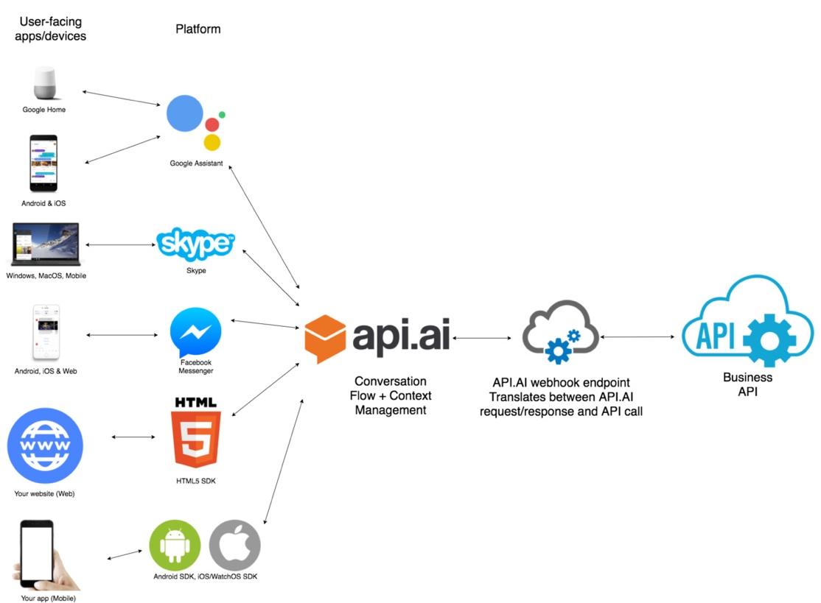

Figure 7 DialogFlow(api.ai) structure (source: https://labs.kunstmaan.be/blog/hey-google-what-can-you-do)

Entities could be for example Entities are Dialogflow's mechanism for identifying and extracting useful data from natural language inputs. [21]

The Entity Animal contains multiple different animals, e.g. dog, cat, bird, etc.

After creating a list of things that are part of the “Animal” Entity you can also help the A.I. by providing synonyms. E.g. A “Puppy” is also a Dog, “Dogs” can also be interpreted as Dog, etc.

Intents are actions that can be derived from phrases the user tells the program. E.g. “Tell Me A Joke” would be an intent, the program will be prompted to execute the task (intent). Like for entities, the developer needs to provide the algorithm with example sentences that should trigger the intent. The more examples are given, the more non predefined sentences the A.I. can use to trigger the intent.[22]

#### Pricing

**Dialogflow Standard Edition** provides all of the core features of Dialogflow, but interactions are limited by usage quotas, and support is provided by the community and e-mail. It is ideal for small to medium businesses that want to build conversational interfaces or those who want to experiment with Dialogflow.

**Dialogflow Enterprise Edition** provides higher usage quotas and support from Google Cloud support. Dialogflow Enterprise Edition is a premium offering, available as a pay-as-you-go service. It is ideal for businesses that need an enterprise-grade service that can easily scale to support changes in user demand.

Available in two pricing plans:

**Essentials** This plan contains all features offered by Dialogflow Standard Edition, plus enterprise-ready quotas for speech recognition, speech synthesis, and telephony gateway.

**Plus** This plan contains all features offered by Essentials, plus enterprise-ready quotas for knowledge connectors. Each request from an Enterprise Plus agent performs the regular intent recognition and entity extraction, as well as a knowledge connector search. See figure 8 for more details.

Figure 8 DialogFlow Pricing (source: https://dialogflow.com/pricing)

#### Siri Assistant

Siri is…The development environment of Siri is called SiriKit (see figure 9) and it offers the possibility to translate calls to the assistant into calls for the app you want to use. For this to work an internet connection is mandatory as the voice data is sent to apple servers for the natural language processing.

Apple has a strict List of so-called Domains and Intents which the application call has to be assigned to for it to work.[23]

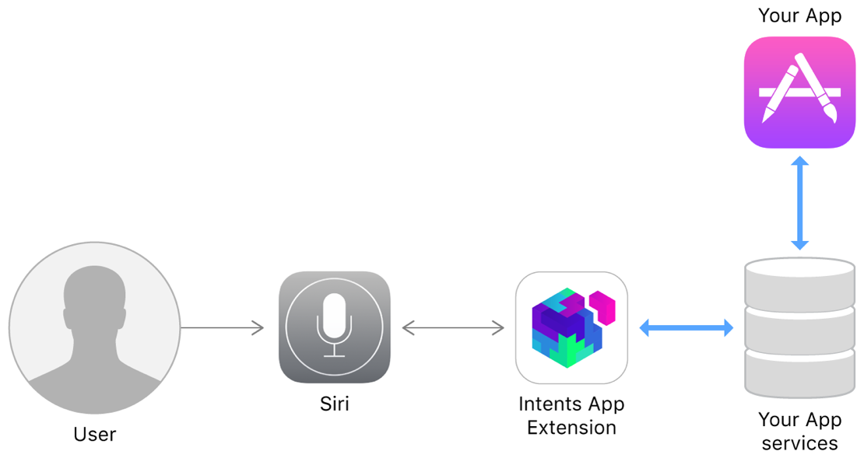

Figure 9 Making services avaliable from Siri and Maps (source: https://developer.apple.com/documentation/sirikit)

#### Domains[23]

* **Lists**: Simple list creation and editing
* **Visual Codes**: Display QR codes
* **Ride Booking**: Requesting a ride, this is intended for services like Uber
* **Messaging**: Simple text messaging
* **Photo Search**: Making a search request for photos and videos and display them.
* **Payments**: Creating a payment request or sending money
* **VoIP Calling**: Make a call (also supports video)
* **Workouts**: Starting, pausing and finishing a routine, explicitly specified as workout
* Climate and radio.

#### Pricing

The pricing of Siri API is dependent on the Tier of choice. See figure 10 for details.

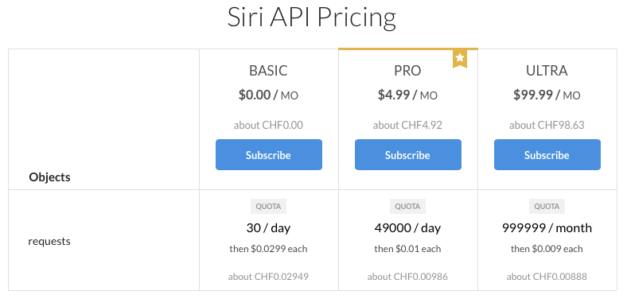

Figure 10 Siri Pricing (source: https://rapidapi.com/pannous/api/siri/pricing)

#### Alexa Voice Service (AVS)

AVS (see figure 11) is a platform independent service that is used over an HTTP/2 api.[24]

AVS is task oriented. A client interacting with the Alexa Voice Service will regularly encounter events/directives that produce competing audio. [25]  
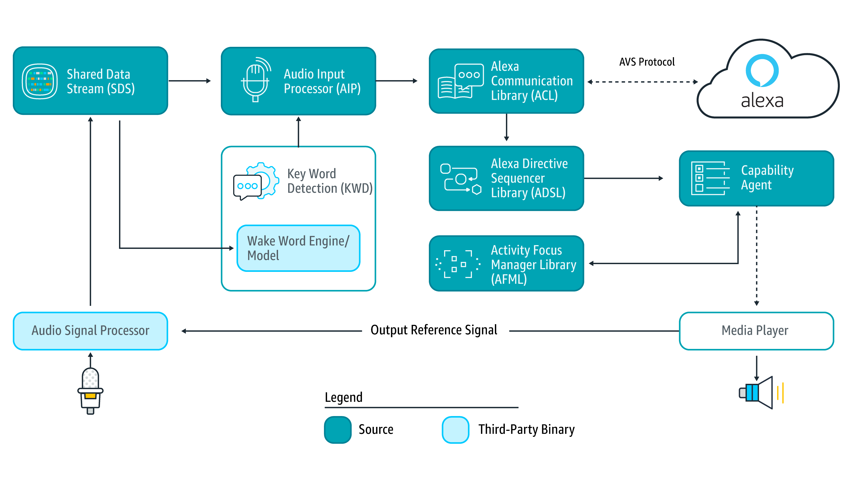

Figure 11 AVS structure (source: https://www.digikey.in/en/articles/techzone/2018/feb/rapid-prototyping-smart-voice-assistant-raspberry-pi)

#### Capabilities[26]

* **Alerts**: timer and stopwatch features.
* **AudioPlayer**: control music playback, etc.
* **Bluetooth**: manage Bluetooth connections.
* **Do Not Disturb**: enable Do Not Disturb mode on device.
* **Equalizer Controller**: control equalizer settings and equalizer modes.
* **Interaction Model**: Allow the client to support complex interactions and Alexa routines.
* **Notifications**: API for notifications.
* **Playback Controller**: navigate playback queue via GUI or buttons.
* **Speaker**: volume control, mute and unmute.
* **Speech Recognizer**: API for speech capture.
* **Speech Synthesizer**: Text to Speech API.
* **System**: System state.
* **Template Runtime**: visualize metadata of requests.

#### Pricing

The pricing of AVS is dependent on the Tier of choice to apply. See figure 12 for more details.

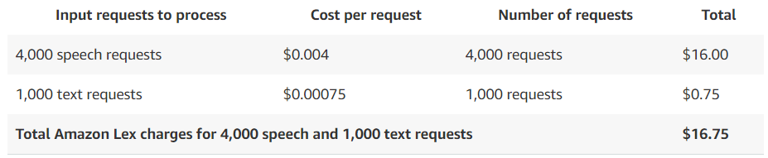

Figure 12 Amazon Voice Services (AVS) pricing (source: https://aws.amazon.com/lex/pricing/)

### Plugins for Text-To-Speech

Beside the built-in Text-To-Speech APIs, there are also multiple plugins that could be used to generate voice using text, as also called Text-To-Speech (TTS) plugins.

#### Xam.Plugins.TextToSpeech

This plugin has been developed a famous Nuget plugins developer “James Montemagno”, and it is a simple and elegant way of performing Text To Speech across Xamarin.iOS, Xamarin.macOS, Xamarin.Android, Windows and Xamarin.Forms projects. [27]

This plugin has been downloaded about 1.5M [27] times till the time of writing this report.

#### Platform Support

The supported platforms are listed in figure 13.

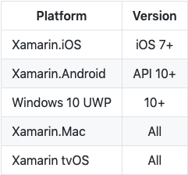

Figure 13 supported platforms (source:https://github.com/jamesmontemagno/TextToSpeechPlugin)

#### Features[27]

* Speak back text.
* Pitch.
* Volume.
* Speak rate.
* Locale/Language of Speech.
* Gather all available language to speak in.

#### 

#### Google.Cloud.TextToSpeech.V1

Is recommended Google client library to access the Google Cloud Text-to-Speech API, synthesizes natural-sounding speech by applying powerful neural network models. [28]

This plugin has been downloaded 16.5K [28] times till the time this sub-chapter has been written.

The usage of this API is not straight forward as it requires some extra pre-usage steps and authentications. [28]

#### Platform Support

Google claims that they are trying to support as much set of environments as possible [29], although they have acknowledged that there exists some issues regarding Universal Windows Platform (UWP). [29]

#### Snow.Xam.Plugins.TextToSpeech

This plugin has been developed by “Ivan Petrov” and it is described by the developed as a plugin for Xamarin and Windows to perform text to speech functionality. [30]

The plugin has been downloaded 893 times [30] till the time this sub-chapter has been written.

#### Supported platforms

Not specified by developer. But it is worth mentioning that this plugin has not been updated since august 2017. [30]

#### Features

The developer claims that it should be possible to adjust the pitch, speak-rate and locale using this plugin. [30]

### Programming Language

This chapter will discuss the major available options to choose from when it comes to develop a Cross-Platform mobile application developing language.

#### XAMARIN Forms

Xamarin is a framework and a set of tools to make it possible to do native Android, iOS & Windows development in C# (.Net).

With a **C#-shared** code base, developers can use Xamarin tools to write native Android, iOS, and Windows apps with native user interfaces and share code across multiple platforms. Xamarin integrates with [Visual Studio](https://www.visualstudio.com/), Microsoft's IDE for the .NET Framework, extending Visual Studio for Android and iOS development. [31]

#### Features

* Native UI, native API access and native performance.
* Anything you can do in Objective-C, Swift, or Java you can do in C# with Xamarin.
* Cutting-edge apps with same-day support for new OS releases. [31]

#### Cons

Using Xamarin, you still won’t be capable of using numerous open-source libraries for iOS and Android development because of **compatibility issues**. The **free version is seriously limited** for developing a substantial project. [31]

#### PhoneGap

PhoneGap is best suited for mobile applications that **don’t make substantial use of the phone’s native features**. It packages your applications within**a native application container** which allows **JavaScript** to access device-level APIs the same way normal apps do. [31]

#### Features

* It allows creating **hybrid apps using** popular web technologies (HTML5, CSS3 and JavaScript), which are also readily available skill sets
* It lets you deploy a single code base to different platforms including iOS, Android, Windows Phone, BlackBerry, Firefox OS and more
* It follows a plugin-able architecture, which means that access to native device APIs and more can **be extended in a modular** way. [31]

#### Cons

The performance is known to be a bit poor for graphic-intensive apps made using PhoneGap. Though you may easily find plugins for PhoneGap per requirements, they could be somewhat outdated or unsupported based on the target platform(s). [31]

#### Codename One

**Codename One** is a cross-device platform with goals of **simple usability, rapid application development**, deep integration with the native platform with possible native speeds. While you’re required to **code in Java**, your application can also be tested & verified with Codename One’s simulator devices and test automation tools. [31]

#### Features

#### It supports most of the popular IDEs like NetBeans, Eclipse, IntelliJ IDEA, etc.

* Its ‘lightweight architecture’ allows the UI to work seamlessly across all platforms
* Its build servers allow building native iOS apps without a Mac machine and native Windows apps without a Windows PC
* It uses ParparVM which guarantees compatibility with future iOS versions because of its use of the officially supported iOS toolchain. [31]

#### Cons

Codename One’s default **visual themes are a bit primitive** and its **Graphical UI Builder may not be very suitable for large projects**. With growing project’s complexity, maintaining a single file with all event handlers becomes very cumbersome. [31]

#### Gluon Mobile

A new open source deep learning interface which allows developers to more easily and quickly build machine learning models, without compromising performance. Gluon provides a clear, concise API for defining machine learning models using a collection of pre-built, optimized neural network components.

Gluon is a tool in the **Machine Learning Tools** category of a tech stack.[32]

#### Features

* Gluon offers a full set of plug-and-play neural network building blocks, including predefined layers, optimizers, and initializers.
* Gluon enables developers to define neural network models that are dynamic, meaning they can be built on the fly, with any structure, and using any of Python’s native control flow.
* Gluon does not require the neural network model to be rigidly defined, but rather brings the training algorithm and model closer together to provide flexibility in the development process.
* Gluon provides all of the above benefits without impacting the training speed that the underlying engine provides. [32]

#### Cons

Lack of developers community engagement, documentation and online tutorials. [32]

Others

### Chatbot service platforms

This chapter will discuss the available chatbots platforms in details, which may host SEEA interaction questions, and the Tags extraction process.

#### Dialogflow

Dialogflow previous known as API.ai is a Google-owned developer of human-computer interaction technologies based on natural language conversations. [33]

#### Ease of use

Dialogflow provides a web interface to create bots which makes it easy to even non-techies to create basic bots. The basic attributes such as Intents, Entities, Actions are easy to understand and configure. Companies are using Dialogflow to build natural and rich conversational experiences. [33]

#### Integrations

Dialogflow provides integration with Google Assistant, websites, Slack, Facebook Messenger, Skype, Twitter, and many others. [33]

#### Cost

Standard edition which is ideal for small to medium businesses is Free. Enterprise plan starts with 0.002$ per request. [33]

#### Supported languages

At the moment it supports around 20 languages [34], ~~some are :~~

* ~~English.~~
* ~~German.~~
* ~~Dutch.~~
* ~~French.~~
* ~~Swedish.~~
* ~~Spanish.~~

#### Amazon Lex

Amazon Lex service is used for building conversational interfaces in your application using voice and/or text. It is powered by the same deep learning technologies as Alexa. [33]

#### Ease of use

Lex provides a web interface to create and launch bots. [33]

#### Integrations

Currently, the integration support is limited to Facebook, Kik, Slack and Twilio SMS. [33]

#### Cost

You are charged based on the number of text or voice requests processed by your bot.

Voice requests are charged at $0.004/request while text requests are priced at $0.00075/request.

For the first year, 10,000 text requests and 5,000 speech requests per month are free. [33]

#### Supported languages

Currently, Lex supports only US English.[35]

#### IBM Watson Assistant

Watson Assistant is an offering for building conversational interfaces into any application, device or channel. Watson has support for searching for an answer from the knowledge base and also have the capability to hand over to a human. [33]

#### Ease of use

IBM Watson Assistant provides a good and easy to navigate user interface. Once you create an account, you will get video tutorials and ready to use samples to quickly get started. First, you need to create a Skill and then go to Assistant to integrate it with other channels. [33]

#### Integrations

You can connect Watson with Facebook Messenger, Slack, Voice Agent (Telephony), WordPress plug-in and also custom applications through APIs. [33]

#### Cost

There are multiple plans available starting from free plan for up to 10,000 messages per month. Paid plan starts with Standard at $0.0025/message. [36]

#### Supported languages

Most of the language Watson supports are in beta. Supports 10+ languages (in BETA) including English, Spanish, Japanese, Italian, Chinese etc. [37]

#### Wit.ai

With wit.ai, you can easily create text and voice-based bots and connect them to their preferred messaging platform. [33]

#### Ease of use

Wit.ai provides UI to setup intents and test it out. Wit.ai is very developer centric and non-techies will have a hard time understanding it. [33]

#### Integrations

Direct integrations through the web interface are not present, all integrations are through HTTP APIs, and libraries available in Node js, Python, Ruby and Go. [33]

#### Cost

Wit is free, both for personal and commercial use. [38]

#### Supported languages

Supports 50+ national and regional languages including English, Spanish, Afrikaans, etc. [33]

#### Azure Bot Service

Microsoft’s Azure Bot Service is used for creating intelligent bots. [33]

#### Ease of use

The web interface is available to create and publish bots which is fairly easy to understand. [33]

#### Integrations

The chatbot created through Azure Bot Service can be published to different channels such as Web, Facebook Messenger, Skype and Skype for Business, Microsoft Teams, Slack, etc. [33]

#### Cost

Azure bot service comes with a free plan of 10,000 messages/month. Post that, pricing is $0.50 per 1,000 messages. Apart from this, they also charge you for resources consumed on Azure functions and Azure web app. [33]

#### Supported languages

Supports multiple languages such as English, French, German, Spanish, etc. [33]

# Concept

This chapter will discuss the approach perused while designing the app and important features introduced in the solution.

## Approach

The User Centric Design (UCD) was the approach to take, as it will help the team to find out which features do the end-users wish to have, the design structure that would suit their needs and the information flow that would make the most sense for them while using the app.

The UCD approach power is its tools used to develop an understanding of the users to a specific level, where the team can then carry on with the design process using the brainstorming method to come up with a list of features that will help to satisfy the user’s needs, by evaluating the solution against the requirements.

## App Map

The screen navigation of the Swiss Engineering Event App (SEEA) is described in figure 14, where each box is a screen, completed arrow is a navigation line and the dotted/dashed lines are either contained pages or conditions that must be fulfilled in order to be able to navigate.

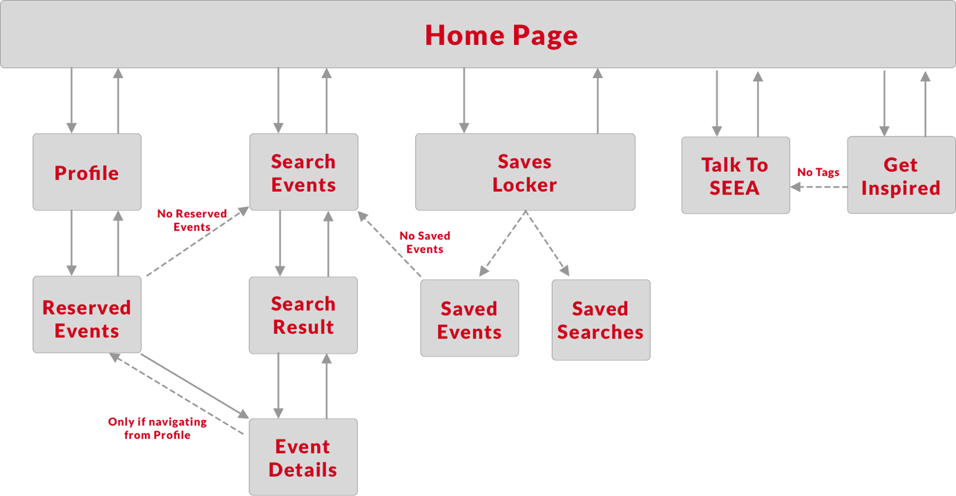

Figure 14 Swiss Engineering Event App map and screen navigation

## Persona

~~The client were asked to describe a typical member of Swiss Engineering in order to start establishing a persona that matches those characteristics.~~

The app is targeting the Swiss Engineering members, who are mainly engineers starting mid 30’s, looking for events which might give them a quick brief into what is new and available in the market, so that the members can choose then to go deep into the presented topic in the events or pass it and look for another topic that may be interesting.

Another Persona were constructed as well to address the non-member end-user.

## User Interface

All the main features that the app presents are located on the home page, and the user will be asked to return to the home page whenever a navigation form a feature to another is wished.

The app features are ordered based on their importance to the app on the home screen, so “Talk to SEEA” is presented at the top, followed by “Searching for events” and “Get Inspired” which suggests events to the user, and then at the bottom the user may find “Saves Locker” and the “Profile” buttons.

The features are presented this way so that the end-user does not struggle searching for the function requested, and to have a better overview about the capabilities of the app from the start.

A shade of the red color is used as the main brand color, where a shade of “cyan”, which happens to be the inverse of that red, is used to highlight the clickable buttons that does not have a great impact on the user experience.

## Requirements

The User Centered Design approach perused implies that the end-user is the responsible of giving the requirements either by interviews or observation.

All the end-users interviewed expressed that they will never use the voice assistant feature for instance to search for events, rather search via text input.

The short scope of voice assistant, as it is only responsible of extracting the tags from the sentences, led to skip using a chatbot for this version as a voice assistant controller and responses generator, and rather extracting the tags via Contains() and After() methods then saving them into the users own profiles.

The end-users interviewed also mentioned that they would rather have all the search criteria entered in one screen rather than splitted into multiple screens, where each has its own criteria to be entered, in order to save time and not having to tap multiple times to reach their results, therefor an old design was altered in order to address those inputs.

Facebook Marketplace, YouTube and even Ricardo do all have a section where content is being suggested to the user, that might be found interested. So such a feature is important to have, as it would help give the user an exceptional personalized experience as it recommends events using the personal liked tags/topics, and also help the client to get more events booked.

The client also approved a suggestion that the searched event must not be in more than five years from the date the search is initiated in, the purpose of that is to make the search process more realistic as there will be no events offered to book before five years of their dates.

## Social Factor

Because Swiss Engineering is in core an organization that gathers a lot of engineers.

According to resent Harvard Business Review, engineers had the second loneliest profession, where lawyers take the lead.

The findings may not come as a big surprise. Engineers spend a lot of time working on their designs in front of their computers. Technology allows them to collaborate and coordinate with colleagues instead of meeting with them face-to-face. Their work environment doesn’t always allow them to form friendships with colleagues.

The Swiss Engineering event app has also this aspect considered, and tries to provide a an anti- loneliness platform to the Swiss Engineering members.

# Prototype

This chapter discuss the set of features presented by the Swiss Engineering Event App as well as the design characteristics and schematic UX design. Here: Explain the new TAG feature that most features will base on.

## App main features

The set of functions to be presented in the app are as follows.

### Talk To SEEA

Where the end-user will be able to interact with the built in voice Assistant to enter the preferred Tags, so that the suggestion the Get Suggestion Page improves.

### Get Inspired

Where a list of suggested events based on the tags entered to SEEA been shown. And also the events that has been suggested based on the Social Factor that has been discussed previously.

### Search events

Search event is the core feature, no event app can be accomplished and no good level of user experience can be offered without including this functionality.

### Profile

The profile page will include all the personal data of the user, beside a tab to navigate to the booked events and a Dark theme toggle button to enable the Dark mode, to address the sample of end-users who liked this theme.

### Saves Locker

Saves Locker is the feature that will enable the end-user the possibility to save events and searches, so that it is all kept under one place, but elegantly separated to enable the ease of access to the required data fast.

In the following sub-chapters, the core features implemented as well as some explorative features are discussed.

## Core implemented features

Both Tags system and “Talk To SEEA” are related, as the voice assistant feature included extracts the tags from the user input, either via voice or text, and then tries to suggest new events to the end-user by comparing those extracted tags and the tags included in each event.

### Tags System

The Tagging System idea is to create a set of tags corresponding to each events, those tags help to identify the content of each event and to which technical field it belongs.

The tags can be constructed from the description of each event, or entered manually as each event object is created by the Swiss Engineering platforms admin.

Those tags can be used later on to refer events to members interested in those tags, or to filter the results of event searching process.

The Tagging System is the core of implementing the voice assistant feature in the Swiss Engineering event app, as there is no other way to save tags into the users profile but with interacting with basic AI called SEEA.

The importance of the Tagging system is that it offers the ability to classify the events into more useful and meaningful clusters, and will help to retrieve even better results when it comes to search for events, as well as suggesting relevant events tailored to the users events and past booking. The extra system business value is that it offers the possibility to know which types of events are the end-user mostly interested in, so that the client might have an insight and can optimize the attendance rate and minimize the no-shows.

### Talk To SEEA

~~The idea of having Voice Assistant feature were requested by the client, however finding its purpose of existing, function and the results that it should deliver was left to the team to develop.~~

Talk To SEEA has two modes, the first is the text mode, in which the end-user will choose to enter the input textually, and SEEA shall respond also in text. The end-user might choose also to give the input via voice, and in that case SEEA will also respond via voice, but both end-users and SEEAs input will still be shown as text, so that the end-user might still check if SEEA got what was said correctly, and that the end user may refer to the textual output in case the end-user didn’t get what SEEA said correctly.

Talk To SEEA enables the end-user to have a conversation with the built-in Assistant (see figure 15 and figure 16), so that the end-user may enter the Tags that the end-user find interesting, to use those tahs then to re-direct events to the Get Inspired page, in order for them to be suggested to the user.

If the end-user entered Tags were found, SEEA will show also a small action button in the suggestions bar that opens the Get Inspired page.

In order to implement the Voice Assistant, the Xam.plugins.TextToSpeech is used to generate the voice out of the textual result generated by the simple AI implemented, due to its good reputation (Number Of Downloads), simplicity and no pre-usage conditions nor authentication like Google.Cloud.TextToSpeech.

Figure 15 Talk to SEEA via voice

Figure 16 Talk to SEEA via text

### Create familiarity in society

The idea of the the Co-Attendees is to recommend events to an end-user based on a Social Factor. was formalized to take a step, and act against the loneliness. It

Lorenzo for instance, based on the new bookings of members who attended the same event with him previously, so if Lorenzo attended an event with Wing earlier, the new booking of Wing should be suggested to Lorenzo as well (see figure 17) but anonymously, so that Lorenzo doesn’t know based on whom this event is being suggested, rather just labeled and listed under the Social Factor findings.

Of course the members are not forced to get to know those familiar people, but it is rather just a push from the Swiss Engineering towards this step, while the final decision is totally up to the end-user.

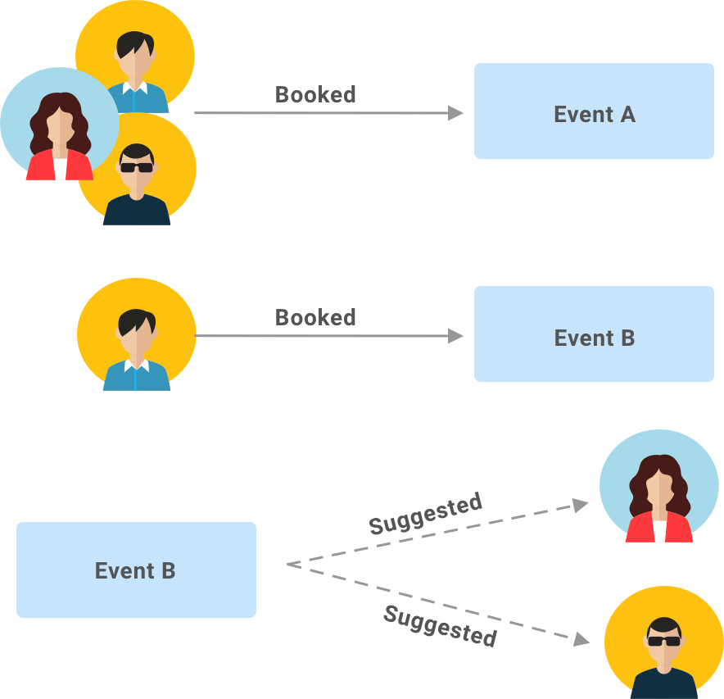

Figure 17 suggest based on former co-attendees

## Explorative features and functionality

This sub-chapter discuss some the features and functions that were explored during the early phases of the app design and prototypes, but were not feasible to implement in the first version of the app, rather in future versions. For the full list of features explored refer to the appendix chapter.

### EventTinder

The Idea of EventTinder is to swipe right for the tags that the end-user is interested in, or to swipe left in case the end-user has chosen to not hear anything about this tags(topic) anymore (see figure 18).

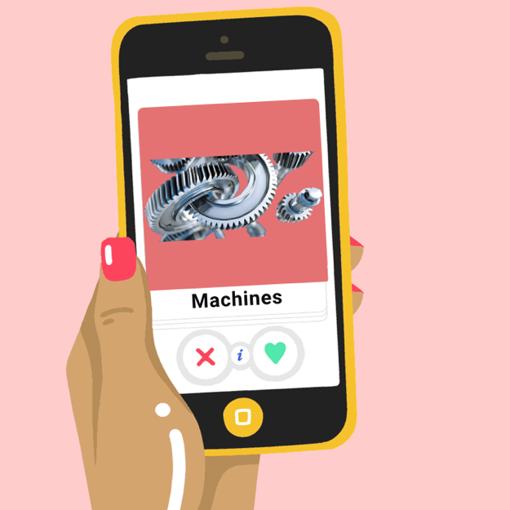

Figure 18 EventTinder

### TagsSquare

The idea of TagsSquare is to drag and drop the visible card into one of the four corners, where each corner represent the end-users level of interest about the name shown on the card (see figure 19). The events that belong to the tag will be often suggested based on the side selected, where by green suggest every single event that contains this tag, and never by red.



Figure 19 TagsSquare

### Search Event by voice

Using this feature, the end-user will enter the search criteria via voice, so the user may say “Search for user design events in Zurich” and the app must retrieve the results and show it on the screen if any. But it was removed afterwards as the intuition of this feature was questioned, and after the feedback of the end-user which stated that they will most probably not use it, and rather search for events using the classical textual input approach.

### Add to my Calendar

The idea is to simply ask the enabled voice assistant to save the event shown on the screen to the calendar app, or an integrated calendar feature inside the app itself. Because the feasibility of implementing an integrated calendar into the app was questioned, therefor the event shall be imported into one of the existing calendar on the users device.

### Booked events query

The idea is to enable the user to ask the built-in assistant about the users personal schedule, the user may say “when is my next event?” and then the assistant shows the next event description screen if any were found (see figure 20 for general steps required).



Figure Booked events query

## Mock-ups

Prototyping and creating Mock-ups was the key of reaching a state of the design, that assures all parties, that this app will deliver a high level of user experience design and usability, as well as finding out the flaws in design at early stages before changing them become costly.

### Get inspirational designs

**“Good artists copy, great artists steal”[39]**, the team interpretation of this quote is that the design should not copy the other designs one to one, but rather follow their steps to come up with a design that fulfils the clients requirements and the end-users needs.

Therefor an intensive research has been made to create an inspirational board, which to be found in the appendix, and some sketches were done via papers to see how the sample of the end-users would react towards those suggested designs.

### Paper prototype (Low-Fi)

The paper prototype was meant to be use as a guidance on how to navigate through the screens, and where to place the features, buttons and represent the app major and minor functions.

Therefore the app home screen was first designed by placing all the major features on the home page (figure 21). so that the end-user who is according to our Persona definition not really an expert in apps overall, and the end-user technical affinities differ by a big margin, don’t have problems finding what is looked for, and that shall also reduce the time needed to accomplish a single task.

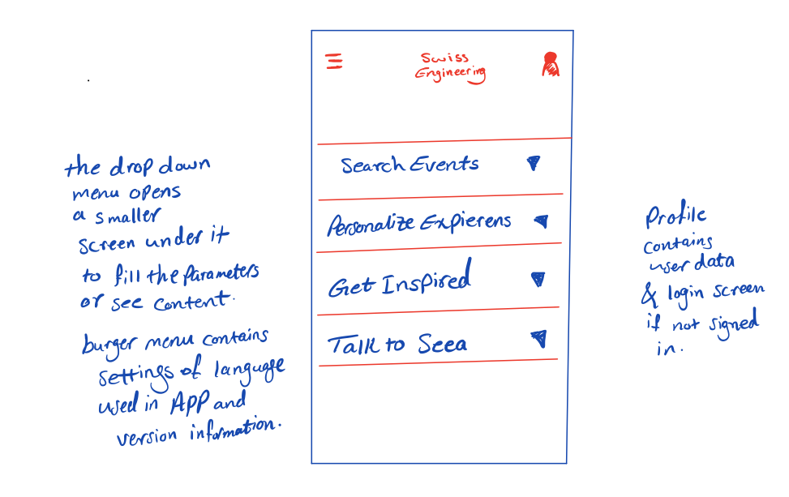

Figure 21 Home screen first concept

The idea of the first design is to include all the elements into one screen, and use drop down views to capture all the needed inputs before the navigating to the second screen of each feature. The design story in details can be found in the appendix.

But the problem with this design according to the end-users feedback, is that all elements are compacted into one single screen, which is not a good thing as it requires two clicks right from the start to do an action, also an irrelevant elements will still be shown in the same screen, although the end-user intent is to do some totally different task, for instance the Search Event tab at the top will still be shown even though the end-user clicked on Personalize Experience tab. Overall the design was not really liked by the end-users sample, therefore a new design has to be found, which is the current Swiss Engineering Event App home screen.

After solving the Homepage screen, it was time to test the navigation system through some of the features, the Search for Events for instance. Which looked like this in the first design.

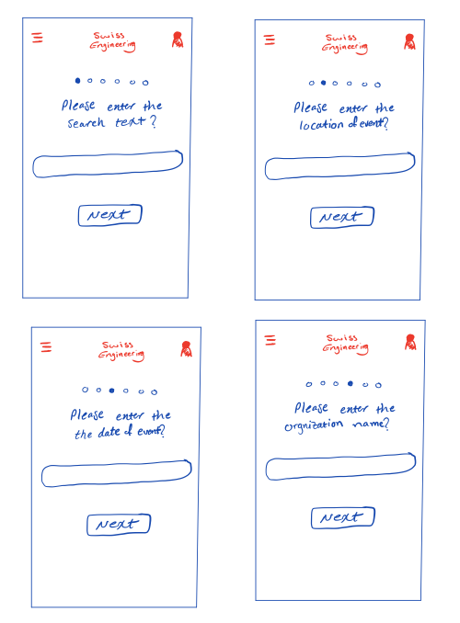

Figure 22 gathering the user input in steps

The idea was simply to have a specific information entry screen for each attribute, and the number of steps needed (screens to come) is displayed by the empty dots at the top (see figure 22), where the filled dot meant to be the users current location in the entry queue.

A major problem of this design is that, first, the end-user is supposed to leave all the fields empty in order to retrieve the list of all available events with no search criteria/filters applied. Second, it takes the end-user 7 clicks to reach the goal, which is the list of events, and 7 clicks back to edit one of the criteria, ~~which was really the case when the end-users feedback were gathered.~~ The solution was to adapt a search feature design by any other app, which is a single screen to collect all the criteria to apply. A full list of experimental screens can be found down in the appendix.

### Hi-Fi Prototype (Sketch Project)

The following Hi-Fi prototype (see figure 23) was done to assure that every UI element, color and user interaction satisfies both the end-users and clients needs. The full story of the Hi-Fi prototype evolvement is included in the appendix.

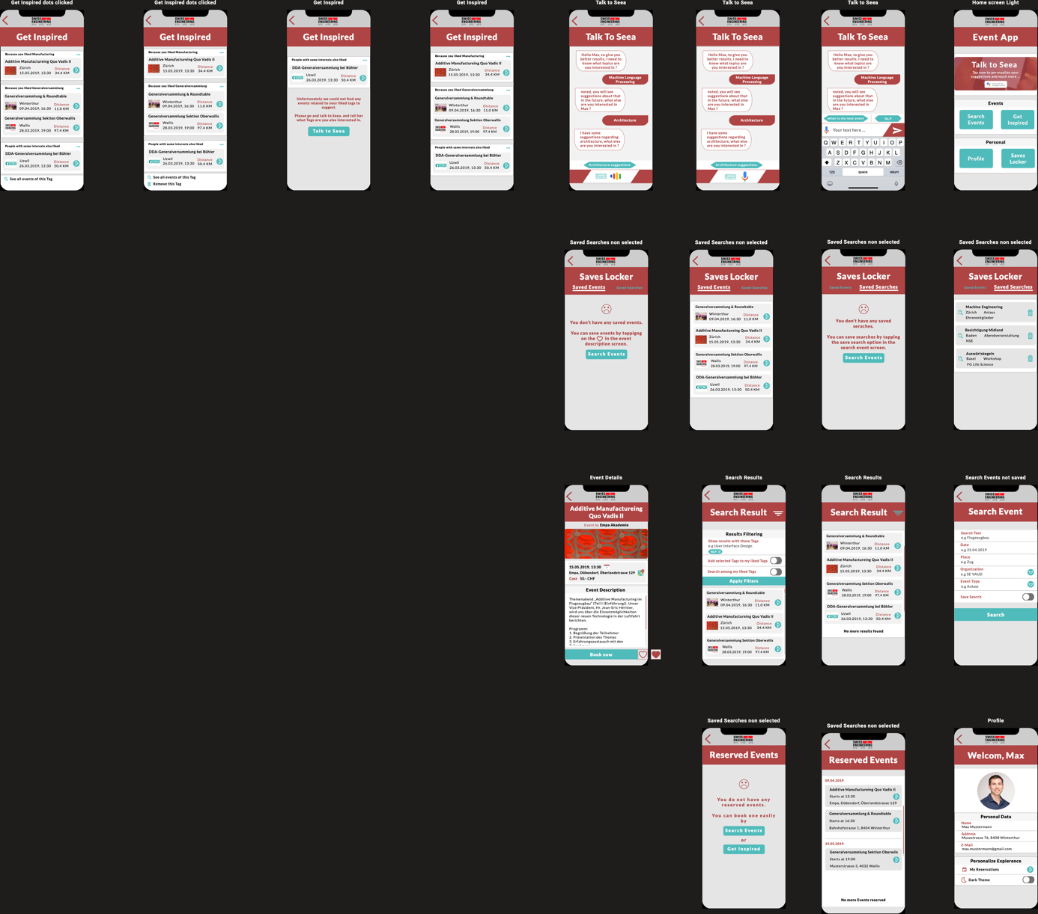

Figure 23 Sketch Hi-Fi prototype

# Implementation

This chapter will discuss the code part of the Swiss Engineering event app and the logic behind the functions.

All the important used external plugins would be addressed as well to illustrate their roles.

Overall design of the application? Software Architecture, graphs, overview of functionality, screens of the final prototype? Used technologies? What were the decisions and why did you use specific libraries/technologies?

## Talk To SEEA

Talk To SEEA has one screen that shows the interaction between the end-user and the simple AI called SEEA.

The screen has a stacklayout object, that contains those interactions ordered chronologically, where the most recent comes at the end.

private void add_new_seea_msg(String msg) {

//construct a SEEA chat frame with the correct colors.

SeeaTalkFrame new_msg = new SeeaTalkFrame(Seea_talk_bg_color, Seea_talk_text_color, Seea_talk_border_color);

//set the response inside the frame constructed.

new_msg.Text = msg;

//Add the frame to the stacklayout.

chat_messages_stack.Children.Add(new_msg);

//scroll to the end of the screen to include the added message (frame) in the scope.

chat_message_scrollview.ScrollToAsync(new_msg, ScrollToPosition.End, false);

}

Code snippet 1 add message to SEEA chat

This stacklayout contains both messages of SEEA and the user, where the color of each helps to differentiate.

The idea behind Talk To SEEA is that it detects what comes after specific words, namely “I am interested in <tag>”, “I love <tag>” or “I like <tag>” where tag is the name of the topic the user is interested in and wishes to receive suggestions about in the future.

This detection is done via Contains() and After() methods applied on strings where both textual or voice input is converted into string first, then using REGEX this string is trimmed so that only what comes after the trigger words is left.

This detected tag is then being saved and compared to the events to see which contains this tag, so that that event is being suggested to the user and previewed in the Get Inspired page.

### Handling users input

Talk To SEEA interaction has two different models. The following sub-chapters will discuss briefly how the users input is being handled and parsed into a string so that the tag can be extracted form.

#### Interacting via text

The user in this mode must enter the tag name as illustrated previously via text using the virtual keyboard (see figure 24).

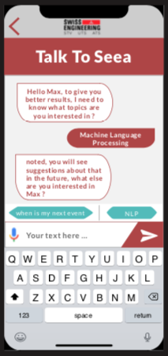

Figure 24 entering the users input via text

In this mode there is no need to use any extra plugin to convert the input, as it is already a string (text).

#### Interacting via voice

The user in this mode must enter the input via voice (see figure 25). The speech must contain one of the mentioned above forms in order for SEEA to be able to extract the tag.

Figure 25 SEEA is not listening as the mic figure appears

The user is expected to tap on the mic button in order for SEEA to start listening, then while listening the mic image shall change to indicate that SEEA is now listening (see figure 26).

Figure 26 SEEA is now listening as the figure indicates

This switching between figures shall provide an extra layer of privacy to the user, as SEEA is only listening when the user sees the listening figure on the screen.

In order to provide the ability to capture the users speech, the existing Speech-To-Text provided on the mobile device is being used (see figure 27). Therefor are two classes “**SpeechToTextImplementation.xaml.cs**” implemented, one in each project for each platform – iOS and Android – to use the built-in Speech-To-Text APIs.

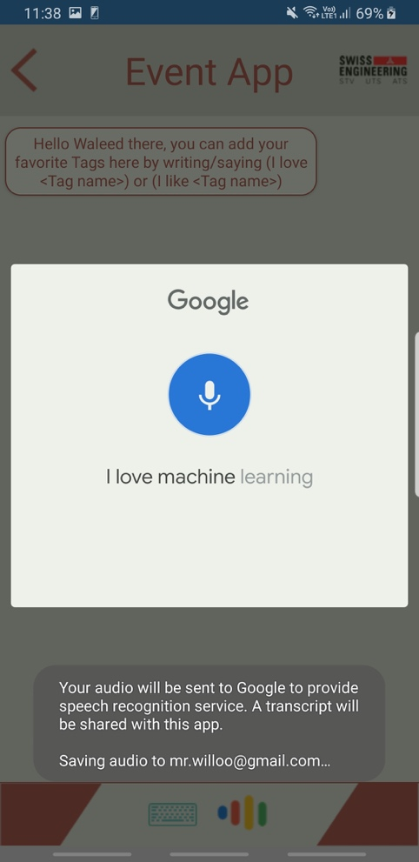

Figure 27 Google Speech-To-Text API is being used on Galaxy S9+ device running Android 9

The method StartRecordingAndRecognizing() is the responsible of capturing the users speech, and also handling the cases where the speech is a complete silence for instance.

try

{

var voiceIntent = new Intent(RecognizerIntent.ActionRecognizeSpeech);

voiceIntent.PutExtra(RecognizerIntent.ExtraLanguageModel, RecognizerIntent.LanguageModelFreeForm);

voiceIntent.PutExtra(RecognizerIntent.ExtraPrompt, "Speak now");

voiceIntent.PutExtra(RecognizerIntent.ExtraSpeechInputCompleteSilenceLengthMillis, 1500);

voiceIntent.PutExtra(RecognizerIntent.ExtraSpeechInputPossiblyCompleteSilenceLengthMillis, 1500);

voiceIntent.PutExtra(RecognizerIntent.ExtraSpeechInputMinimumLengthMillis, 15000);

voiceIntent.PutExtra(RecognizerIntent.ExtraMaxResults, 1);

voiceIntent.PutExtra(RecognizerIntent.ExtraLanguage, Java.Util.Locale.Default);

_activity.StartActivityForResult(voiceIntent, VOICE);

}

Code snippet 2 Android Speech-To-Text API usage in class SpeechToTextImplementation.cs

iOS implementation on the other side is more complex, as it creates an instance of AVAudioSession to record the users speech, and then uses the SFSpeechRecognizer to create what is called a transcript of the users speech.

_audioEngine.Prepare();

_audioEngine.StartAndReturnError(out nsError);

_recognitionTask = _speechRecognizer.GetRecognitionTask(_recognitionRequest,

(result, error) =>

{

var isFinal = false;

if (result != null){

_recognizedString = result.BestTranscription.FormattedString;

MessagingCenter.Send<ISpeechToText, string>(this, "STT",

_recognizedString);

_timer.Invalidate();

_timer = null;

_timer = NSTimer.CreateRepeatingScheduledTimer(2, delegate

{

DidFinishTalk();

});

}

if (error != null || isFinal){

MessagingCenter.Send<ISpeechToText>(this, "Final");

StopRecordingAndRecognition(audioSession);

}

});

Code snippet 3 a part of the implementation of StartRecordingAndRecognizing inside the SpeechToTextImplementation.cs for iOS project

ISpeechToText interface has two important functions which are StartSpeechToText and StopSpeechToText which are implemented inside the SpeechToTextImplementation.cs classes in both projects.

This interface is used inside the portable project to call the correct implementation of the class SpeechToTextImplementation.cs whether it was the iOS or Android verison depending on the mobile device which the app runs on.

try

{

speechRecongnitionInstance = DependencyService.Get<ISpeechToText>();

}

catch (Exception ex)

{

Log.Warning(ex.Message, "");

}

Code snippet 4 calling the correct class that implements ISpeechToText interface

The users input can be then accessed in the portable project using a list that contains the users sentence called inputs.

List<String> inputs = new List<String>();

String platform = Device.RuntimePlatform;

Code Snippet 5 the inputs list inside the portable project

The list has in each index the so far detected sentence. Because of that are the last two indexes duplicated (see figure 28), as the previous before the last contains the sentence with the last word detected, and the last one contains the full sentence detected.

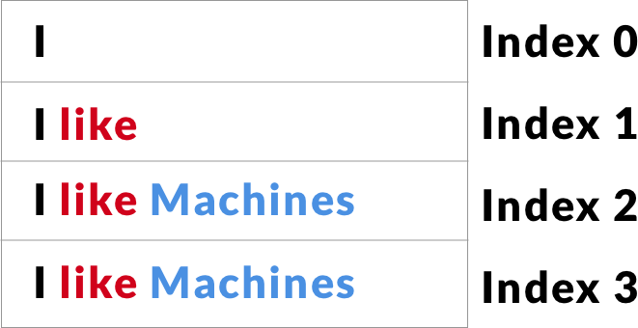

Figure 28 how are the words captured inside the inputs list

Therefor SEEA shall wait till the last two indexes are equal, then take the last one and handle it as the actual users input.

if ((inputs.Count != 0))

{

if (inputs.ElementAt(inputs.Count - 1) ==

inputs.ElementAt(inputs.Count- 2))

{

if (platform == "iOS")

{

mic_btn.Source = "googleMic.png";

add_new_user_msg(inputs.ElementAt(inputs.Count - 1));

TriggerSeeaRespond(inputs.ElementAt(inputs.Count - 1));

inputs = new List<String>();

}

}

}

Code snippet 6 comparing the last two indexes inside the inputs list

### Extracting the tag from the users input

Extracting the tags – topics names – is done using Contains() and After() methods applied on the stringified user input. A set of predefined sentences must be said in order for the simple AI behind SEEA to extract the tag name from the sentence, those sentences are as mentioned above “I am interested in <tag>”, “I love <tag>” or “I like <tag>” where tag is the name of the topic the user is interested in.

private String ExtractTagFromUserInput(string userInput) {

string tag = "";

if (userInput.ToLower().Contains("like")) {

tag = userInput.After("like");

}

else if (userInput.ToLower().Contains("love")) {

tag = userInput.After("love");

}

else if (userInput.ToLower().Contains("interested in")) {

tag = userInput.After("interested in");

}

return tag;

}

Code snippet 7 extracting the tag from the sentence using Contains() and After() methods inside TalkToSeeaScreen.xaml.cs class in portable project

### Generating SEEA response

This chapter will discuss the process of generating the response to the users input either via voice or text.

#### Generating the textual response

SEEA generates the response by combining both the extracted tag name form the users input, and the pre-entered response string located inside the resource translation resx file named “AppResources.resx”.

<data name="seeaResponse" xml:space="preserve">

<value>has been saved and you will recieve suggestions based on that.

What else are you interested in ?</value>

</data>

Code snippet 8 SEEA response upon successfully saving the users entered tag name

The combination process is located inside the TalkToSeeaScreen.xaml.cs file. The combination process does simply concatenate the name of the tag extracted and the loaded translated response from the resource file.

public String CreateSEEAResponse(string tagName)

{

String seeaResponse = ExtractTagFromUserInput(tagName) +

" "+AppResources.seeaResponse;

return seeaResponse;

}

Code snippet 9 CreateSEEAResponse method which handles the combination process

The result of this phase is a string containing the SEEA response textually, this string is being placed inside the frame of SEEA response.

The frame of SEEA response is being created by code, and not using a UI builder, and can be found inside the SeeaTalkFrame.cs file.

This frame contains a Text property that shall contain the SEEA response.

In order to display the frame on the chat screen, it shall be added to the stacklayout called “chat_messages_stack” (see code snippet 1).

chat_messages_stack contains both the users as well as SEEA messages, and what is differentiating those two to the user is their location on the screen, whether on the left or the right side as well as their colors, where SEEA responses are presented with a shade of red and the users are in white.

<StackLayout x:Name="chat_messages_stack"

VerticalOptions="StartAndExpand"/>

Code snippet 10 chat_messages_stack declaration in TalkToSeea.xaml

In case the user did not use the virtual keyboard to enter the input but rather the voice, the textual response generated shall be then parsed to a speech response using the Xam.plugins.TextToSpeech 4.0.0.7 plugin.

The usage of this plugin is done via calling the Speak() function inside the CrossTextToSpeech class implemented in the plugin installed.

TriggerSeeaRespond() method checks which input entering method has been used by checking the visible views, either the text or the speech view, to determine whether to call the Speak() method or not after adding the SEEA chat frame to the chat stacklayout as shown in the following code snippet.

public void TriggerSeeaRespond(String userInput) {

//call the method to create the response.

String seeaRespond = CreateSEEAResponse(userInput);

//add the response to the screen by calling SEEA side adding method.

add_new_seea_msg(seeaRespond);

//speak out loud the response if the user input was via voice.

if (input_text.IsVisible == false) {

CrossTextToSpeech.Current.Speak(seeaRespond);

}

}

Code snippet 11 TriggerSeeaRespond() implemented in TalkToSeeaScreen.xaml.cs

## Search for events

Search for events feature consists of three main screens, where in the first screen implemented in “SearchEventScreen.xaml.cs”, the user would enter the search criteria, or leave it empty to view all events available. The event date entered by the user has to follow a set of rules in order for it to be accepted, those rules are as follows.

* The date can not be in more than five years from the date of search.
* The date entered must be in the format of **DD.MM.YYYY.**
* The date must consist of only numbers. No letters are allowed.
* The date must be logically correct, so the day must be in the interval between 1 and

31, the month between 1 and 12 and the year in maximum 5 years from now.

private bool IsDateAccepted(String[] dateGiven)

{

if (IsSizeOfDate(dateGiven))

{

if (IsDateJustNumbers(dateGiven))

{

if (IsDateLogicallyCorrect(dateGiven))

{

if (IsDateInTheFuture(dateGiven))

{

return true;

}

}

}

}

return false;

}

Code snippet 12 the function that calls the four indicated checks

The second screen is implemented in “SearchResult.xaml.cs” and is responsible of searching for the results using the criteria passed from the previous screen and presenting the search results in a table, or show a message indicating that there were no results found in case the criteria entered did not match any of the available events.

This screen uses the following plugins.

### Xam.plugins.Forms.ImageCircle 3.0.0.5

This plugin is used as a custom control for Xamarin.Forms project to turn images into elegant circle images. It offers also customizable border, thickness and color. [40]

This plugin has been used to preview the events image in a circle mask inside the resulted events table.

### Rg.Plugins.Popup 1.1.5.188

This plugin is for Xamarin forms. It allows to open any page as a popup view. [41]

This plugin is used in particular to view the extra filter options available on the search result screen by clicking on the top right burger menu button.

The third screen is implemented in “EventDetails.xaml.cs” in which the tapped event information on the previous screen is shown to the user, so that the user can decide whether to book the event, add the event to the liked events list, add the event information to an existing calendar on the device or/and view the events location on the official map app offered by the devices operating system manufacturer.

This screen has used a multiple of external plugins in order for it to deliver the extra functionality, those plugins are as follows.

### Plugin.Persmissions 3.0.0.12

Simple cross platform plugin to request and check permissions. [42]

This plugin is used to obtain the permissions from the user, when the user taps on the calendar icon in the events details page.

### CClarke.Plugin.Calendars 1.0.0

This plugin Perform basic CRUD calendar operations on iOS/Android/UWP through a simple common API. [43]

This plugin is used after the permissions being granted by the user to access the calendars.

The plugin access the calendars and then preview their names to the user, so that the user can choose which calendar to save the events to.

The calendars are shown in a popup view, which has been implemented using the Popup plugin mentioned previously.

## Get Inspired

Due to the time restriction and the lack of man resources in the team, this feature had to be dropped in this version.

## Profile

Profile screen contains the users saved personal data on the Swiss Engineering platform database. The user is able to preview the name, email, address and a personal photo (see figure 29).

The profile screen has also a button that enables the user to navigate to the screen of the booked events.

Figure 29 Profile screen with my reservations button at the bottom

The views appeared on the BookedEvents.xaml are decided based on the size of the booked events list. If there are no booked events then a warning label will be shown instead the table of the booked events.

public void DecideAppearingViews()

{

//hide the table view and show the warning label if no events booked were found

if (StaticLists.bookedEventsList.Count == 0)

{

eventsTable.IsVisible = false;

emptyListLabelIsVisible.IsVisible = true;

}

//if events were found, then show the table and hide the warning label.

else

{

emptyListLabelIsVisible.IsVisible = false;

eventsTable.IsVisible = true;

}

}

Code snippet 13 decide which views to appear in BookedEvents.xaml.cs

The booked events are presented in a chronological order, where the events that are on the same date are grouped under the same header, which is the date.

The way those booked events are grouped and ordered in code is by using a LINQ inside the BookedEvents.xaml.cs file.

This LINQ creates a Collection that contains a list of a list of events, in other words, for each index there exist a key which is a date string, and a value which is another list, this list is the events that are in the same date as the header stringfied date.

var items = from eventAvaliable in StaticLists.bookedEventsList

orderby eventAvaliable.EventDate.ToString()

group eventAvaliable by

eventAvaliable.EventDate.Substring(0,10)

into eventsGroup

select new Grouping<String,Event>(eventsGroup.Key.ToString(),

eventsGroup);

Code snippet 14 LINQ inside BookedEvents.xaml.cs

When the user clicks on an event from the list, the user will navigate to the EventDetails.xaml page, where the tapped events data will be displayed.

## Saves Locker

Saves Locker is a tabbed page that contains both the saved events as well as the saved searches (see figure 30).

The user can navigate between those two by tapping on the navigation bar located at the bottom of the screen for both iOS and Android.

Figure 30 Saves Locker screen with Saved Searches displayed

The placement of the navigation bar is by default on iOS at the bottom of the screen, but in order to alter this behavior to work for Android as well, the SavesLockerScreen.xaml file description at the top has to be edited to contain two lines of code shown on the following code snippet 15.

xmlns:android=

"clr-namespace:Xamarin.Forms.PlatformConfiguration.AndroidSpecific;

assembly=Xamarin.Forms.Core"

android:TabbedPage.ToolbarPlacement="Bottom">

Code snippet 15 altering Android navigation bar placement in SavesLockerScreen.xaml

### Saved Searches screen

The saved searches screen as shown in Figure 30 contains a list of the saved searches. Tapping on those searches will initiate a search query with the values indicated on the tapped table cell applied as a search criteria. Those criteria can be accessed and passed as arguments of the tapped item.

public async void ToSearchResults(object sender, ItemTappedEventArgs eventArgs)

{

Search eventTapped = eventArgs.Item as Search;

await Navigation.PushAsync(new SearchResult(eventTapped.SearchText,

eventTapped.Date, eventTapped.Place,

eventTapped.Organization,

eventTapped.EventType));

}

Code snippet 16 initiating a search query using the tapped search arguments

Tapping on the recycle bin located inside the cell will lead to delete the saved search record.

This delete process can be done by binding the image of the recycle bin inside the cell to the content “search criteria” of the cell itself.

Therefor when a recycle bin is being tapped on, a command will be executed to remove the search object binded to that recycle bin from the list of saved searches.

private void DeleteSearch(object sender, EventArgs e)

{

var image = sender as Image;

var searchToRemove = image?.BindingContext as Search;

//execute the command only on the cell that its image was tapped on.

RemoveSearchCommand.Execute(searchToRemove);

//refresh the content of the table.

decideAppearingViews();

}

public Command<Search> RemoveSearchCommand

{

get

{

return new Command<Search>(

(Search search) => {

StaticLists.savedSearches.Remove(search);

});

}

}

Code snippet 17 removing a search object binded to a recycle bin image

If the list of saved searches is empty, then a label shall be displayed to indicate that no search criteria has been saved yet.

public void decideAppearingViews()

{

if (StaticLists.savedSearches.Count == 0)

{

searchesTable.IsVisible = false;

emptyListLabelIsVisible.IsVisible = true;

}

else

{

emptyListLabelIsVisible.IsVisible = false;

searchesTable.IsVisible = true;

}

}

Code snippet 18 DecideAppearingViews() controls what views to show according to the number of elements inside the booked events list

### Saved Events screen

The saved events screen is the other tabbed page inside the Saves Locker.

This screen contains all the events that the user liked or saved by clicking on the heart image (see figure 31) in the events detail screen.

Figure 31 tapping on the heart icon bottom right would either save or un-save the event, depending on the emptiness level of the heart

The list of saved events (see figure 32) may contain either a table showing a list of saved events by the user, or a warning label indicating that there were no saved events found.

Figure 32 The list of saved events with two events saved

The method OnAppearing()[44], which is a virtual overridden method that is declared in the Xamarin.Forms namespace, is the responsible of deciding which one of both views to show, based on the number of elements inside the saved events list.

protected override void OnAppearing()

{

likedEventsList = CreateListOfLikedEvents(StaticLists.eventList)

.ToList<Event>();

//if no liked events were found, then show the warning label and hide the table.

if (likedEventsList.Count == 0)

{

emptyListLabelIsVisible.IsVisible = true;

eventsTable.IsVisible = false;

}

//otherwise show the table of liked events and hide the warning label.

else if (likedEventsList.Count != 0)

{

eventsTable.IsVisible = true;

emptyListLabelIsVisible.IsVisible = false;

}

eventsTable.ItemsSource = likedEventsList;

}

Code snippet 19 OnAppearing() inside SavedEvents.xaml.cs

The saved events are not stored inside a separate list, rather is IsSaved a property of Event object, so when the user saves an event, this property is set to true, and by default it is set to false.

This helps to toggle either the full heart figure or the empty heart in the Event Details screen, by checking if the IsSaved property of that specific event displayed, whether it is set to be true or false, where true will be presented then as the full heart, and false by the empty heart.

Inside the SavedEvents.xaml.cs a new temporary list is created to contain only the saved events, in order to present those on the table.

public static List<Event> CreateListOfLikedEvents(IList<Event> listOfAllEvents)

{

List<Event> matchedList = new List<Event>();

  foreach (Event e in listOfAllEvents)

{

if (e.IsSaved == true)

{

matchedList.Add(e);

}

}

return matchedList.ToList();

}

Code snippet 20 CreateListOfLikedEvents() iterates through the list of all events to check whether they have been saved or not

When the user clicks on an event displayed, the user will be navigated to the event details screen, where the user can book the event, or un-save it.

After un-saving the event, the event will not be shown anymore inside the list of saved events when the user clicks on the back arrow inside the event details page because the OnAppearing() method mentioned earlier updates the list each time the screen of saved events is displayed.

# Analysis and future thoughts

This chapter will discuss the final thoughts, self-review for the application presented as well as future improvements that shall be considered in the up-coming versions.

### Conclusion

At the beginning the team focused on understanding what elements does XAMARIN offer us the developers to deal with and what limitations do exist. Then the decision were made, considering the Personas, to offer the simplest type of designs that the Persona can deal with and have no problems understanding how to interact with the elements and navigating through the available screens. Therefor the main screen includes all the core features buttons, distributed into two groups, while the main feature of the app, which is the built in assistant feature, is represented at the top in full width.

The app offers an intuitive workflow to accomplish the end-users goal, and contains simple user interface elements, that the user must know already its meaning and what is its purpose, based on end-users previous experience dealing with the other apps.

VOICE

### What went well

~~The project did not fall and proceeded despite all the unfortunate complications that happened during the semester.~~

Most of the features presented were covered by this show-case application, although not in the same way they were thought to be at the beginning of the semester.

The solution ideas are meant to be capable of overcoming all the obstacles that the website has, and the added value was present in most of the ideas thought of and well documented.

The plugins used were well integrated to achieve their purpose of existence.

VOICE

### Lessons learned

~~Because the work-load was not equally distributed, therefor was the~~ time estimation absolutely not accurate, such a point shall be included next time in the risk management plan.

A sufficient time should have been planned for the knowledge-acquisition or self-learning to know what could be done using Xamarin and learn C# programming, because of that some stuff that were implemented at the beginning could have been done in a better efficient way, the knowledge level increased within the time, but that was not enough to refine everything, unfortunately due to the work-load, the time reserved to learn C# and Xamarin were spent either working on some documents or designs, or implementing the solution directly.

The app is till this point not connected to the Swiss Engineering platform database, which is not realistic at all and helps only for a show-case app. The connection should have been established at early phases ~~to plan a sufficient time from the beginning to solve the connection issues if any~~ to allow solving unanticipated implementation problems.

The simple technique of extracting the topic from the users entered sentence works only for the pre-defined trigger sentences, while sometimes the built-in Voice To Text API makes mistakes, the application should have a way to delete the mis-understood unintended tag.

The alignment of some of the user interface elements is not perfect, which may cause that some elements overlap with each other.

The second layer of filtering the search event results does not work, and only there as a placeholder. This should have work if more time could be spent re-structuring the objects and their properties, and also learning how to implement the filtering where two screens are involved “one containing the results and the other contains the filtering options”.

The show-case app does not reflect exactly the design provided by the team, that could have changed if the way the user interface in Xamarin works was known before sketching the design, or if more time could have been spent refining the user interface.

The workflow starts from the main screen and the user is asked to navigate back to the main screen in order to start working with another feature, while this gave the simplicity element, but we would rather have mixed structure instead of a linear workflow. The end-user needs three clicks at max on the back button to go back to the main screen, or as an element of easiness, a click on the logo of Swiss Engineering should bring the end-user back to the main screen as well, although this is not really a mobile application approach and more web-sites, but it was a necessity to implement it this way, in order to really use every single element displayed on the screen.

### Future improvements

The requirements gathering process didn’t include the end-user from the Swiss Engineering Organization, but a sample of potential end-users who are indeed engineers from different fields and backgrounds were consulted in order to know what do they really need in an event app, and what information do they count on to make a booking decision. Nevertheless for a future update, the Swiss Engineering end-users should be consulted and be involved to refine the design and data offered.

The chatbot is an important feature to implement for the voice assistant, because it offers a higher level of artificial intelligence as its training data is way larger than what the developing team can offer. It can handle also the different contexts and intents much better than the pre-defined sentences entered by the developing.

The Swiss Engineering database needs a complete re-design to include all the new attributes used in this show-case app, such as the tags for an event, the description in multiple languages in order for the details to be consistent with the languages that the app supports and also the user personal picture, which is presented in the profile screen.

The database shall contain also the members who visited an event with the user before, in order to offer recommendations for the user to visit the future bookings of those members as well. Although this attribute shall not be accessible by the user personally to not violate the privacy rules.

Finding a suitable assistant service to accomplish the tasks requested, and as the options are limited from the start to choose from three candidates, which are the major player nowadays on the market, namely Google Assistant, Apple Siri and Amazon Alexa, we advise to go with the Google Assistant service for a number of reasons, the most important may be the ease of use, the huge infrastructure, and the tutorials available which are offered by Google.

In combination with Google Assistant, choosing DialogFlow ~~“previously known as api.ai”~~ might be the best option as it was recently aquired by Google, therefor we expect this chatbot platform to be supported more by Google and have extra features available to work along Google Assistant.

An extended list of features should be also added to the built-in assistant to expand the services it offers, and not only to save tags and view answer simple questions, but to book events directly for instance.

The process of reserving events is too inconsistent throughout the different SE chapters and even varies from one event to another. Sometimes the user signs up by contacting the organizers, othertimes direct booking can occur through the website. A consistent process of booking can benefit the user experience for the entire SE Organization in the future. We hypothesize that with the elimination of the current workaround (navigating to the SE website for booking) booking becomes more accessible and attendance rates will be improved.

# Refrences

[1] S. Gladkiy, “User-Centered Design: Process and Benefits,” *UX Planet*, 14-Jun-2018. [Online]. Available: https://uxplanet.org/user-centered-design-process-and-benefits-fd9e431eb5a9. [Accessed: 12-Jul-2019].

[2] “SpecAugment: A New Data Augmentation Method for Automatic Speech Recognition,” *Google AI Blog*. .

[3] S. Toshniwal *et al.*, “Multilingual Speech Recognition With A Single End-To-End Model,” *ArXiv171101694 Cs Eess*, Nov. 2017.

[4] S. Petridis, J. Shen, D. Cetin, and M. Pantic, “Visual-Only Recognition of Normal, Whispered and Silent Speech,” *ArXiv180206399 Cs*, Feb. 2018.

[5] S. Narang and D. Gupta, “Speech Feature Extraction Techniques: A Review,” p. 8, 2015.

[6] S. A. Alim and N. K. A. Rashid, “Some Commonly Used Speech Feature Extraction Algorithms,” *Nat. Artif. Intell. - Algorithms Appl.*, Dec. 2018.

[7] K. I. Nordstrom and P. F. Driessen, “Variable Pre-Emphasis LPC for Modeling Vocal Effort in the Singing Voice,” p. 4, 2006.

[8] N. Dave, “Feature Extraction Methods LPC , PLP and MFCC In Speech Recognition.”

[9] H. Hermansky and N. Morgan, “RASTA processing of speech,” *IEEE Trans Speech Audio Process.*, vol. 2, pp. 578–589, 1994.

[10] N. S. Uchat, “Hidden Markov Model and Speech Recognition,” p. 26.

[11] P. P. Kajave, “Microsoft Word - Finding More Non-supersingular Elliptic Curves for Pairing..,” 2009.

[12] A. H. Mansour, G. Z. A. Salh, and K. A. Mohammed, “Voice Recognition using Dynamic Time Warping and Mel-Frequency Cepstral Coefficients Algorithms,” 2015.

[13] T. Kinnunen, “Comparison of clustering algorithms in speaker identification,” 2000.

[14] D. H. B. Kekre and M. Kulkarni, “Speaker Identification by using Vector Quantization,” 2010.

[15] “Understanding the impact of speech recognition software on search,” *Search Engine Watch*, 29-Sep-2016. .

[16] “Leveraging speech recognition technology in call centers,” *SearchCustomerExperience*, May-2009. [Online]. Available: https://searchcustomerexperience.techtarget.com/report/Leveraging-speech-recognition-technology-in-call-centers. [Accessed: 09-Jul-2019].

[17] “Voice and Speech Recognition,” *FindBiometrics*. [Online]. Available: https://findbiometrics.com/solutions/voice-speech-recognition/. [Accessed: 09-Jul-2019].

[18] “How Voice Assistants Are Changing Our Lives,” *Smartsheet*, 16-Apr-2018. [Online]. Available: https://www.smartsheet.com/voice-assistants-artificial-intelligence. [Accessed: 09-Jul-2019].

[19] J.-0552-M. Campbell, “Speaker Recognition for Forensic Applications,” p. 34, 2014.

[20] “Google Assistant  |  Dialogflow.” [Online]. Available: https://dialogflow.com/docs/integrations/google-assistant. [Accessed: 11-Jul-2019].

[21] “Entities overview  |  Dialogflow.” [Online]. Available: https://dialogflow.com/docs/entities. [Accessed: 11-Jul-2019].

[22] “Intents | Actions on Google,” *Google Developers*. [Online]. Available: https://developers.google.com/actions/reference/rest/intents. [Accessed: 11-Jul-2019].

[23] “SiriKit | Apple Developer Documentation.” [Online]. Available: https://developer.apple.com/documentation/sirikit. [Accessed: 11-Jul-2019].

[24] “Manage an HTTP/2 Connection with AVS | Alexa Voice Service.” [Online]. Available: https://developer.amazon.com/docs/alexa-voice-service/manage-http2-connection.html. [Accessed: 11-Jul-2019].

[25] “Interaction Model | Alexa Voice Service.” [Online]. Available: https://developer.amazon.com/docs/alexa-voice-service/interaction-model.html. [Accessed: 12-Jul-2019].

[26] “Capabilities API | Alexa Voice Service.” [Online]. Available: https://developer.amazon.com/docs/alexa-voice-service/capabilities-api.html#use-cases. [Accessed: 11-Jul-2019].

[27] “Xam.Plugins.TextToSpeech 4.0.0.7.” [Online]. Available: https://www.nuget.org/packages/Xam.Plugins.TextToSpeech/. [Accessed: 16-Jul-2019].

[28] “Google.Cloud.TextToSpeech.V1 1.0.0.” [Online]. Available: https://www.nuget.org/packages/Google.Cloud.TextToSpeech.V1/. [Accessed: 16-Jul-2019].

[29] “Supported platforms | Google Cloud APIs.” [Online]. Available: https://googleapis.github.io/google-cloud-dotnet/docs/guides/platforms.html. [Accessed: 16-Jul-2019].

[30] “Snow.Xam.Plugins.TextToSpeech 2.0.2.” [Online]. Available: https://www.nuget.org/packages/Snow.Xam.Plugins.TextToSpeech/. [Accessed: 16-Jul-2019].

[31] “Top 10 Cross-Platform Mobile Development Tools,” *Hongkiat*, 17-Aug-2016. [Online]. Available: https://www.hongkiat.com/blog/cross-mobile-platform-framework-wora/. [Accessed: 11-Jul-2019].

[32] “Why developers like Gluon,” *StackShare*. [Online]. Available: https://stackshare.io/gluon. [Accessed: 11-Jul-2019].

[33] “Dialogflow vs Lex vs Watson vs Wit vs Azure Bot | What to Choose?,” *Kommunicate Blog*, 10-May-2019. .

[34] “Languages | Dialogflow Documentation,” *Google Cloud*. [Online]. Available: https://cloud.google.com/dialogflow/docs/reference/language. [Accessed: 11-Jul-2019].

[35] “Limits - Amazon Lex.” [Online]. Available: https://docs.aws.amazon.com/lex/latest/dg/gl-limits.html. [Accessed: 18-Jul-2019].

[36] “Watson Assistant Pricing | IBM Cloud.” [Online]. Available: https://www.ibm.com/cloud/watson-assistant/pricing/. [Accessed: 11-Jul-2019].

[37] “Supported languages.” [Online]. Available: https://cloud.ibm.com/docs/services/assistant?topic=assistant-language-support#language-support. [Accessed: 11-Jul-2019].

[38] “Wit.ai.” [Online]. Available: https://wit.ai/faq. [Accessed: 18-Jul-2019].

[39] “Why Great Designers Steal—and Are Proud of It :: UXmatters.” [Online]. Available: https://www.uxmatters.com/mt/archives/2011/04/why-great-designers-stealand-are-proud-of-it.php. [Accessed: 18-Jul-2019].

[40] “Xam.Plugins.Forms.ImageCircle 3.0.0.5.” [Online]. Available: https://www.nuget.org/packages/Xam.Plugins.Forms.ImageCircle/. [Accessed: 20-Jul-2019].

[41] “Rg.Plugins.Popup 1.1.5.188.” [Online]. Available: https://www.nuget.org/packages/Rg.Plugins.Popup/. [Accessed: 20-Jul-2019].

[42] “GitHub - jamesmontemagno/PermissionsPlugin: Check and Request Permissions Plugin for Xamarin and Windows.” [Online]. Available: https://github.com/jamesmontemagno/PermissionsPlugin. [Accessed: 20-Jul-2019].

[43] C. Clarke, *Cross-platform calendar API plugin for Xamarin and Windows: TheAlmightyBob/Calendars*. 2019.

[44] dotnet-bot, “Page.OnAppearing Method (Xamarin.Forms).” [Online]. Available: https://docs.microsoft.com/en-us/dotnet/api/xamarin.forms.page.onappearing. [Accessed: 24-Jul-2019].

# Appendix